What have we been doing this week?

Here are some of our favourite mom

Bella basks.

Jasper’s deep in soft, soapy suds.

Adam and Isher fill and pour rice.

Amos improvises with cone and helmet.

Amelie the bug hunter peeps.

Bella’s busy with glue and scissors.

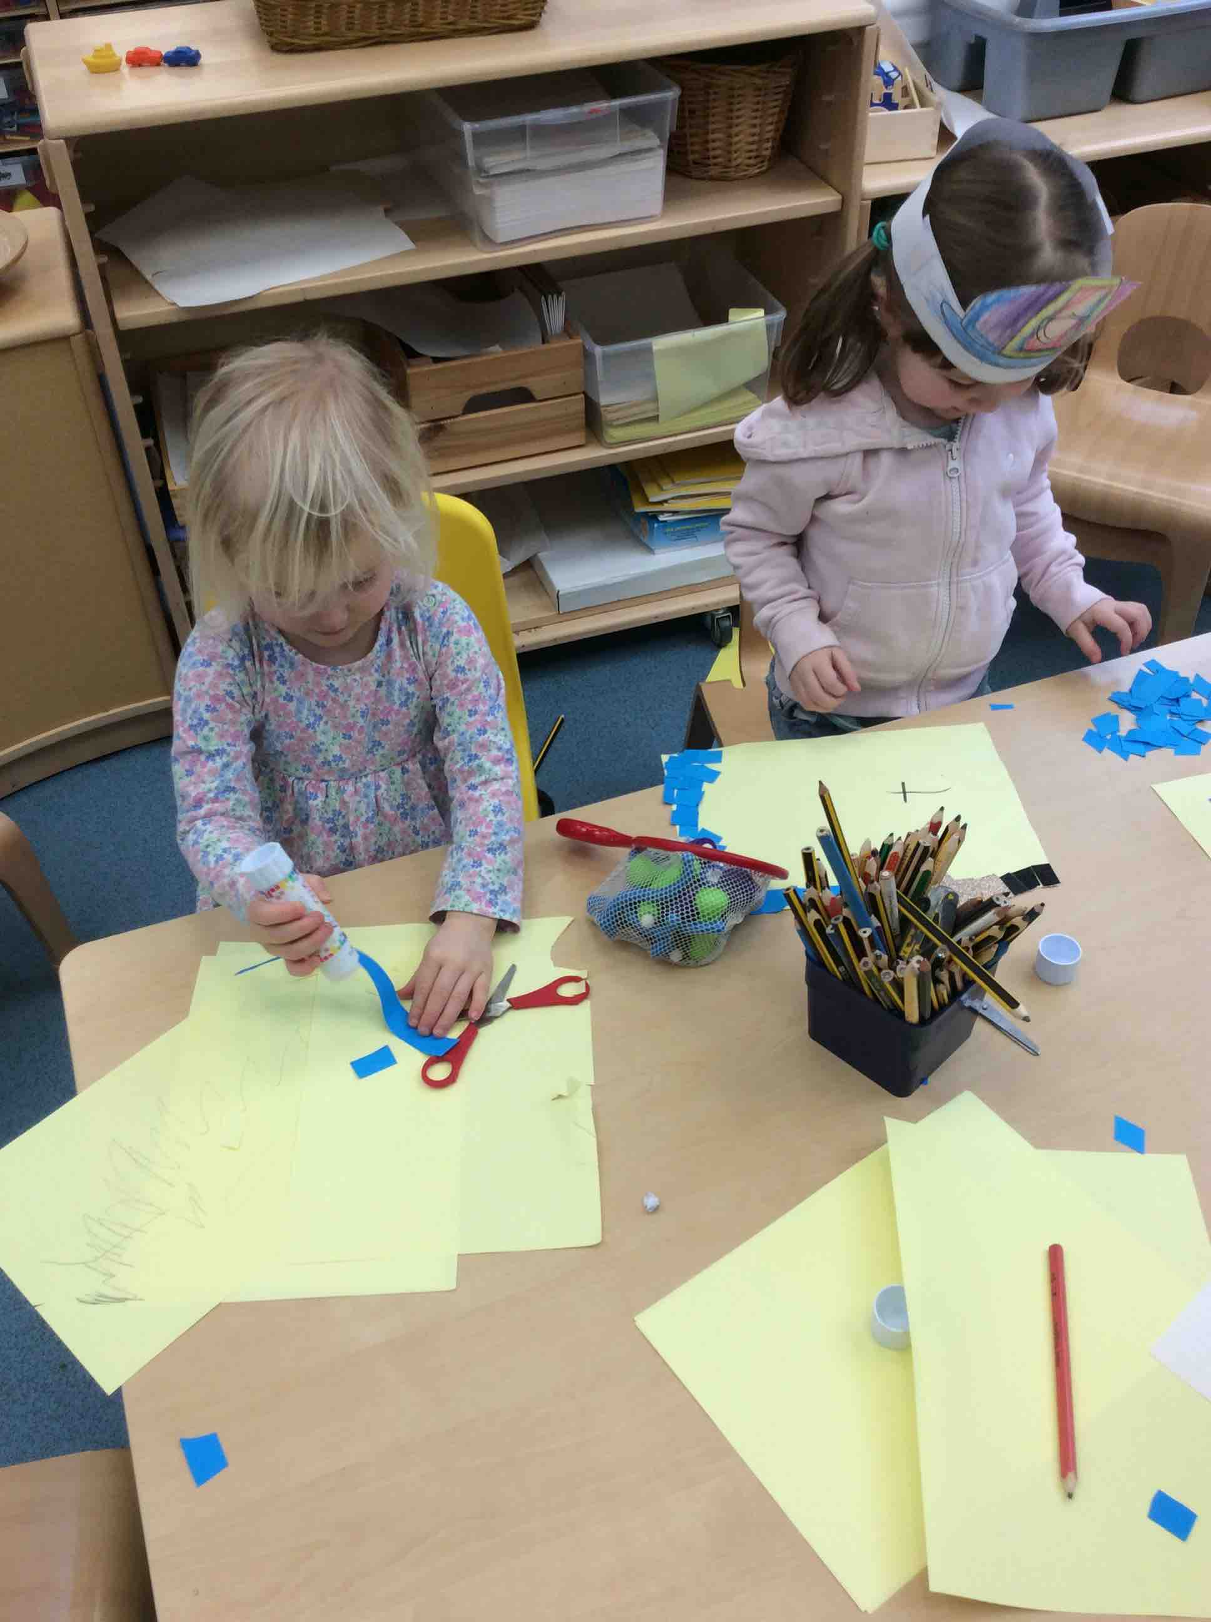

Mikaeel runs for sheer joy.

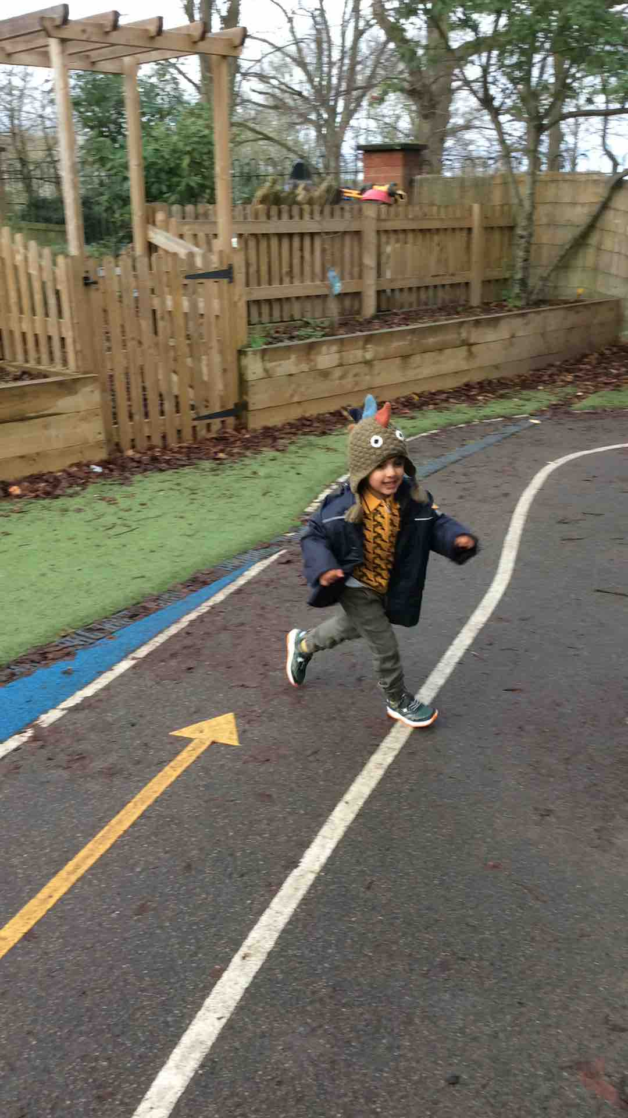

Daphne is our resident artist.

Leonardo and Charlotte roll!

**Characteristics of**

**Effective Learning**

Active Learning:

‘I can begin to predict sequences because I remember routines.’

As we prepare to move areas, Jasper and Arjan are first in the group to hold hands, to make a pair of partners for our walking train. Excellent organisation boys!

Arjan tests out the fence.

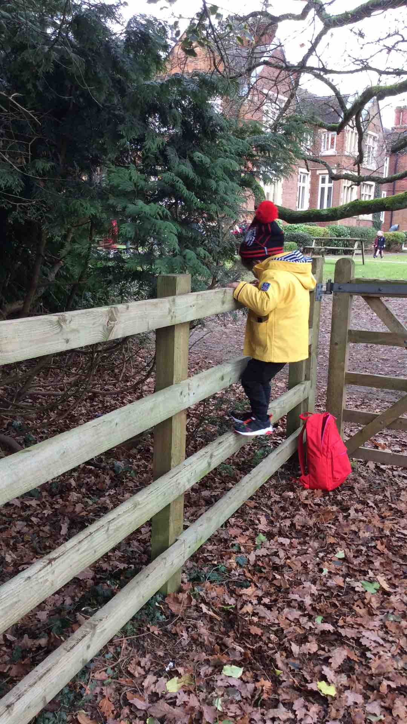

George improves his qwerty keyboard.

